# Working with JSON and Array data in BigQuery

[BigQuery](http://bigquery.cloud.google.com/) is Google's fully managed, NoOps, low cost analytics database. With BigQuery you can query terabytes and terabytes of data without having any infrastructure to manage or needing a database administrator. BigQuery uses SQL and can take advantage of the pay-as-you-go model. BigQuery allows you to focus on analyzing data to find meaningful insights.

This lab is an in-depth walkthrough of working with semi-structured data (ingesting JSON, Array data types) inside of BigQuery. Denormalizing your schema into a single table with nested and repeated fields can yield performance improvements, but the SQL syntax for working with array data can be tricky. You will practice loading, querying, troubleshooting, and unnesting various semi-structured datasets.

Objectives

In this lab, you learn about the following:

* Loading semi-structured JSON into BigQuery
* Creating and querying arrays
* Creating and querying structs
* Querying nested and repeated fields

Open BigQuery Console

In the Google Cloud Console, select **Navigation menu** > **BigQuery**:

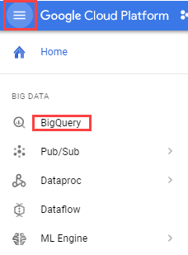

The **Welcome to BigQuery in the Cloud Console** message box opens. This message box provides a link to the quickstart guide and lists UI updates.

Click **Done**.**Create a new dataset to store our tables**

1. In your BigQuery, click on your project name and then **Create Dataset**.

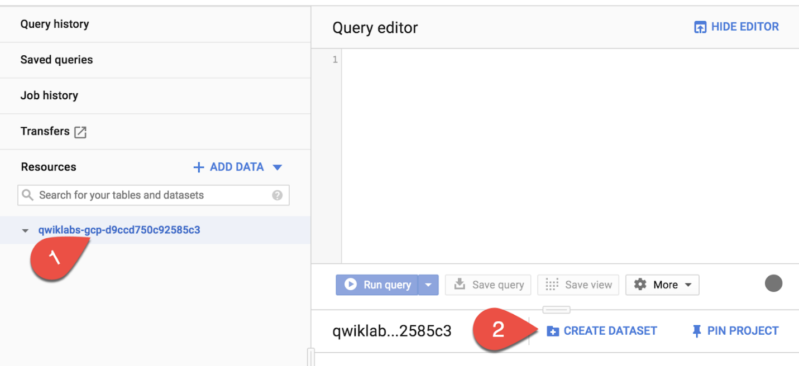

1. Name the new dataset "fruit_store". Leave the other options at their default values (Data Location, Default Expiration). Click **Create dataset**.

**Practice working with Arrays in SQL**

Normally in SQL you will have a single value for each row like this list of fruits below:

|  |  |
| --- | --- |
| **Row** | **Fruit** |
| 1 | raspberry |
| 2 | blackberry |
| 3 | strawberry |
| 4 | cherry |

What if you wanted a list of fruit items for each person at the store? It could look something like this:

|  |  |  |
| --- | --- | --- |
| **Row** | **Fruit** | **Person** |
| 1 | raspberry | sally |
| 2 | blackberry | sally |
| 3 | strawberry | sally |
| 4 | cherry | sally |
| 5 | orange | frederick |
| 6 | apple | frederick |

In traditional relational database SQL, you would look at the repetition of names and immediately think to split the above table into two separate tables: Fruit Items and People. That process is called [normalization](https://en.wikipedia.org/wiki/Database_normalization) (going from one table to many). This is a common approach for transactional databases like mySQL.

For data warehousing, data analysts often go the reverse direction (denormalization) and bring many separate tables into one large reporting table.

What are some potential issues if you stored all your data in one giant table?



The table row size could be too large for traditional reporting databases



Any changes to a value (like customer email) could impact many other rows (like all their orders)



Data at differing levels of granularity could lead to reporting issues because less granular fields would be repeated.



All of the above

Submit

Now, you're going to learn a different approach that stores data at different levels of granularity all in one table using repeated fields:

|  |  |  |
| --- | --- | --- |
| **Row** | **Fruit (array)** | **Person** |
| 1 | raspberry | sally |
| blackberry |  |
| strawberry |  |
| cherry |  |
| 2 | orange | frederick |
| apple |  |

What looks strange about the previous table?

* It's only two rows.
* There are multiple field values for Fruit in a single row.
* The people are associated with all of the field values.

What the key insight? The array data type!

An easier way to interpret the Fruit array:

|  |  |  |
| --- | --- | --- |
| **Row** | **Fruit (array)** | **Person** |
| 1 | [raspberry, blackberry, strawberry, cherry] | sally |
| 2 | [orange, apple] | frederick |

Both of these tables are exactly the same. There are two key learnings here:

* An array is simply a list of items in brackets [ ]
* BigQuery visually displays arrays as *flattened*. It simply lists the value in the array vertically (note that all of those values still belong to a single row)

1. Try it yourself. Enter the following in the BigQuery Query Editor:

*#standardSQL*

SELECT

['raspberry', 'blackberry', 'strawberry', 'cherry'] AS fruit_arraycontent_copy

1. Click **Run query**.
2. Now try executing this one:

*#standardSQL*

SELECT

['raspberry', 'blackberry', 'strawberry', 'cherry', 1234567] AS fruit_arraycontent_copy

You should get an error that looks like the following:

Error: Array elements of types {INT64, STRING} do not have a common supertype at [3:1]

Why did we get this error?



Data in an array cannot exceed 4 elements



Data in an array must only be strings



Data in an array [ ] must all be the same type

Submit

Arrays can only share one data type (all strings, all numbers).

1. Here's the final table to query against:

*#standardSQL*

SELECT person, fruit_array, total_cost FROM `data-to-insights.advanced.fruit_store`;content_copy

1. Click **Run query**.
2. After viewing the results, click the **JSON** tab to view the nested structure of the results.

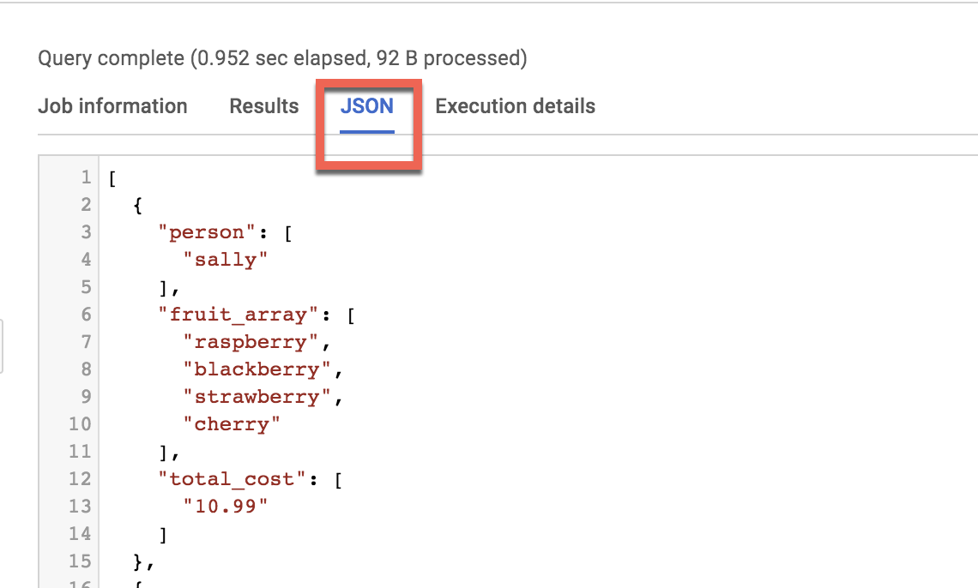

Loading semi-structured JSON into BigQuery

What if you had a JSON file that you needed to ingest into BigQuery?

1. Create a new table in the fruit_store data set.
2. Add the following details for the table:

* **Source**: Choose **Google Cloud Storage** in the **Create table from** dropdown.
* **Select file from GCS bucket**: gs://data-insights-course/labs/optimizing-for-performance/shopping_cart.json **File format**: JSONL (Newline delimited JSON)
* **Schema**: Check **Auto detect** (Schema and input parameters).

1. Call the new table "fruit_details".
2. Click **Create table**.

In the schema, note that fruit_array is marked as REPEATED which means it's an array.

**Recap**

* BigQuery natively supports arrays
* Array values must share a data type
* Arrays are called REPEATED fields in BigQuery

Click *Check my progress* to verify the objective.

Create a new dataset and load JSON data into the table

Check my progress

**Creating your own arrays with ARRAY_AGG()**

Don't have arrays in your tables already? You can create them!

1. **Copy and Paste** the below query to explore this public dataset

SELECT

fullVisitorId,

date,

v2ProductName,

pageTitle

FROM `data-to-insights.ecommerce.all_sessions`

WHERE visitId = 1501570398

ORDER BY datecontent_copy

1. Click **Run** and view the results

How many rows are returned?



70



111



100



2

Submit

1. Now, we will use the ARRAY_AGG() function to aggregate our string values into an array. Copy and paste the below query to explore this public dataset:

SELECT

fullVisitorId,

date,

ARRAY_AGG(v2ProductName) AS products_viewed,

ARRAY_AGG(pageTitle) AS pages_viewed

FROM `data-to-insights.ecommerce.all_sessions`

WHERE visitId = 1501570398

GROUP BY fullVisitorId, date

ORDER BY datecontent_copy

1. Click **Run** and view the results

How many rows are returned?



2 - one for each day



63 - one for each day



70 - one for each day



100 - one for each day

Submit

1. Next, we will use the ARRAY_LENGTH() function to count the number of pages and products that were viewed.

SELECT

fullVisitorId,

date,

ARRAY_AGG(v2ProductName) AS products_viewed,

ARRAY_LENGTH(ARRAY_AGG(v2ProductName)) AS num_products_viewed,

ARRAY_AGG(pageTitle) AS pages_viewed,

ARRAY_LENGTH(ARRAY_AGG(pageTitle)) AS num_pages_viewed

FROM `data-to-insights.ecommerce.all_sessions`

WHERE visitId = 1501570398

GROUP BY fullVisitorId, date

ORDER BY datecontent_copy

How many pages were visted by this user on 20170801?



70



101



109



8

Submit

1. Next, lets deduplicate the pages and products so we can see how many unique products were viewed. We'll simply add DISTINCT to our ARRAY_AGG()

SELECT

fullVisitorId,

date,

ARRAY_AGG(DISTINCT v2ProductName) AS products_viewed,

ARRAY_LENGTH(ARRAY_AGG(DISTINCT v2ProductName)) AS distinct_products_viewed,

ARRAY_AGG(DISTINCT pageTitle) AS pages_viewed,

ARRAY_LENGTH(ARRAY_AGG(DISTINCT pageTitle)) AS distinct_pages_viewed

FROM `data-to-insights.ecommerce.all_sessions`

WHERE visitId = 1501570398

GROUP BY fullVisitorId, date

ORDER BY datecontent_copy

How many DISTINCT pages were visted by this user on 20170801?



109



101



70



8

Submit

**Recap**

You can do some pretty useful things with arrays like:

* finding the number of elements with ARRAY_LENGTH(<array>)
* deduplicating elements with ARRAY_AGG(DISTINCT <field>)
* ordering elements with ARRAY_AGG(<field> ORDER BY <field>)
* limiting ARRAY_AGG(<field> LIMIT 5)

Click *Check my progress* to verify the objective.

Creating arrays with ARRAY_AGG()

Check my progress

**Querying datasets that already have ARRAYs**

The BigQuery Public Dataset for Google Analytics bigquery-public-data.google_analytics_sample has many more fields and rows than our course dataset data-to-insights.ecommerce.all_sessions. More importantly, it already stores field values like products, pages, and transactions natively as ARRAYs.

1. **Copy and Paste** the below query to explore the available data and see if you can find fields with repeated values (arrays)

SELECT

*

FROM `bigquery-public-data.google_analytics_sample.ga_sessions_20170801`

WHERE visitId = 1501570398content_copy

1. **Run** the query.
2. **Scroll right** in the results until you see the hits.product.v2ProductName field (we will discuss the multiple field aliases shortly).

You will notice a lot of seemingly 'empty' cells in the results as you scroll. These cells are grayed out and not marked as null. Why do you think that is?



The entire dataset has no data values for the grayed out cells



The grayed out cells are visual placeholders to make it possible to show each item in an array type column on its own row within the context of a row in the result set



BigQuery is still in the process of loading values for the grayed out cells

Submit

1. The amount of fields available in the Google Analytics schema can be overwhelming for our analysis. Let's try to query just the visit and page name fields like we did before.

SELECT

visitId,

hits.page.pageTitle

FROM `bigquery-public-data.google_analytics_sample.ga_sessions_20170801`

WHERE visitId = 1501570398content_copy

You will get an error: Cannot access field product on a value with type ARRAY> at [5:8]

Before we can query REPEATED fields (arrays) normally, you must first break the arrays back into rows.

For example, the array for hits.page.pageTitle is stored currently as a single row like:

['homepage','product page','checkout']

content_copy

and we need it to be

['homepage',

'product page',

'checkout']

content_copy

1. How do we do that with SQL? Answer: Use the UNNEST() function on your array field:

SELECT DISTINCT

visitId,

h.page.pageTitle

FROM `bigquery-public-data.google_analytics_sample.ga_sessions_20170801`,

UNNEST(hits) AS h

WHERE visitId = 1501570398

LIMIT 10content_copy

We'll cover UNNEST() more in detail later but for now just know that:

* You need to UNNEST() arrays to bring the array elements back into rows
* UNNEST() always follows the table name in your FROM clause (think of it conceptually like a pre-joined table)

Click *Check my progress* to verify the objective.

Querying datasets that already have ARRAYs

Check my progress

**Introduction to STRUCTs**

You may have wondered why the field alias hit.page.pageTitle looks like three fields in one separated by periods. Just as ARRAY values give you the flexibility to *go deep* into the granularity of your fields, another data type allows you to *go wide* in your schema by grouping related fields together. That SQL data type is the [STRUCT](https://cloud.google.com/bigquery/docs/reference/standard-sql/data-types#struct-type) data type.

The easiest way to think about a STRUCT is to consider it conceptually like a separate table that is already pre-joined into your main table.

A STRUCT can have:

* one or many fields in it
* the same or different data types for each field
* it's own alias

Sounds just like a table right?

Let's explore a dataset with STRUCTs

1. Under **Resources** find the **bigquery-public-data** dataset (if it's not present already, use this [link](https://console.cloud.google.com/bigquery?p=bigquery-public-data&d=google_analytics_sample&t=ga_sessions_20170801&page=table) to pin the dataset)
2. Click open **bigquery-public-data**
3. Find and open **google_analytics_sample**
4. Click the **ga_sessions** table
5. Start scrolling through the schema and answer the following question by using the find feature of your brower (i.e. CTRL + F)

In a BigQuery schema, a STRUCT field is noted as a RECORD Type. Search for RECORD in the Google Analytics schema. How many STRUCTs are present in this dataset?



1



5



11



32

Submit

What are the names of some of the STRUCT (RECORD Type) fields?



Totals



TrafficSource



trafficSource.adwordsClickInfo



device



All of the above

Submit

How can both TrafficSource and trafficSource.adwordsClickInfo both be STRUCTs?



A STRUCT can have another STRUCT as one of its fields (you can nest STRUCTs)



They are not STRUCTs



Because they are all ARRAYs



This is an invalid data type

Submit

In a BigQuery schema, an ARRAY field is noted as a REPEATED Mode. Search for REPEATED in the Google Analytics schema. How many ARRAYs are present in this dataset?



1



5



11



32

Submit

1. As you can imagine, there is an incredible amount of website session data stored for a modern ecommerce website. The main advantage of having 32 STRUCTs in a single table is it allows you to run queries like this one without having to do any JOINs:

SELECT

visitId,

totals.*,

device.*

FROM `bigquery-public-data.google_analytics_sample.ga_sessions_20170801`

WHERE visitId = 1501570398

LIMIT 10content_copy

Note: The .* syntax tells BigQuery to return all fields for that STRUCT (much like it would if totals.* was a separate table we joined against)

Storing your large reporting tables as STRUCTs (pre-joined "tables") and ARRAYs (deep granularity) allows you to:

* gain significant performance advantages by avoiding 32 table JOINs
* get granular data from ARRAYs when you need it but not be punished if you dont (BigQuery stores each column individually on disk)
* have all the business context in one table as opposed to worrying about JOIN keys and which tables have the data you need

Click *Check my progress* to verify the objective.

Explore a dataset with STRUCTs

Check my progress

**Practice with STRUCTs and ARRAYs**

The next dataset will be lap times of runners around the track. Each lap will be called a "split".



1. With this query, try out the STRUCT syntax and note the different field types within the struct container:

*#standardSQL*

SELECT STRUCT("Rudisha" as name, 23.4 as split) as runnercontent_copy

|  |  |  |
| --- | --- | --- |
| **Row** | **runner.name** | **runner.split** |
| 1 | Rudisha | 23.4 |

What do you notice about the field aliases? Since there are fields nested within the struct (name and split are a subset of runner) you end up with a dot notation.

What if the runner has multiple split times for a single race (like time per lap)?

How could you have multiple split times within a single record? Hint: the splits all have the same numeric datatype.



Use a SQL UNION to join the race and split details



Store each split time as an element in an ARRAY of splits



Store each split time in a separate STRING field with STRING_AGG()



Store each split time in a separate table called race_splits

Submit

1. With an array of course! Run the below query to confirm:

*#standardSQL*

SELECT STRUCT("Rudisha" as name, [23.4, 26.3, 26.4, 26.1] as splits) AS runnercontent_copy

|  |  |  |
| --- | --- | --- |
| **Row** | **runner.name** | **runner.splits** |
| 1 | Rudisha | 23.4 |
| 26.3 |
| 26.4 |
| 26.1 |

To recap:

* Structs are containers that can have multiple field names and data types nested inside.
* An arrays can be one of the field types inside of a Struct (as shown above with the splits field).
* Practice ingesting JSON data

1. Create a new dataset titled **racing**.
2. Create a new table titled **race_results**.
3. Ingest this Google Cloud Storage JSON file:

gs://data-insights-course/labs/optimizing-for-performance/race_results.jsoncontent_copy

* **Source**: Google Cloud Storage under **Create table from** dropdown.
* **Select file from GCS bucket**: gs://data-insights-course/labs/optimizing-for-performance/race_results.json
* **File format**: JSON (Newline delimited)
* **Edit Schema** then move the **Edit as text** slider and add the following:

[

{

"name": "race",

"type": "STRING",

"mode": "NULLABLE"

},

{

"name": "participants",

"type": "RECORD",

"mode": "REPEATED",

"fields": [

{

"name": "name",

"type": "STRING",

"mode": "NULLABLE"

},

{

"name": "splits",

"type": "FLOAT",

"mode": "REPEATED"

}

]

}

]content_copy

1. Click **Create table**.
2. After the load job is successful, preview the schema for the newly created table:

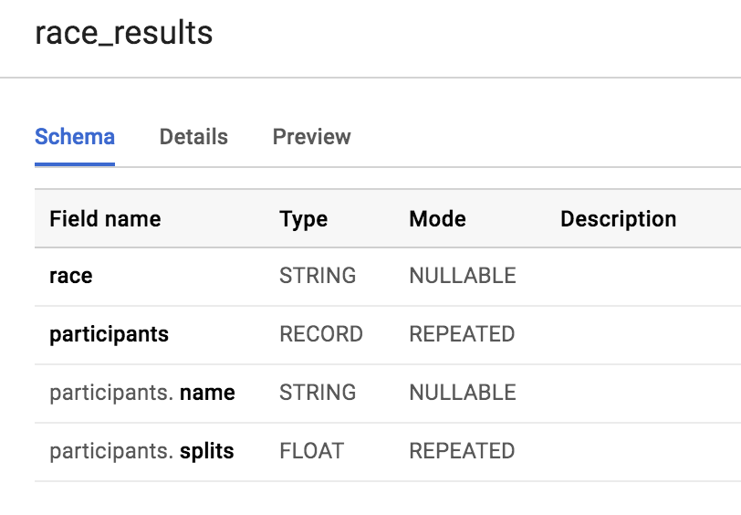

Which field is the STRUCT? How do you know?

The **participants** field is the STRUCT because it is of type RECORD

Which field is the ARRAY?

The participants.splits field is an array of floats inside of the parent participants struct. It has a REPEATED Mode which indicates an array. Values of that array are called nested values since they are multiple values inside of a single field.

Practice querying nested and repeated fields

1. Let's see all of our racers for the 800 Meter race.

*#standardSQL*

SELECT * FROM racing.race_resultscontent_copy

How many rows were returned?

Answer: 1

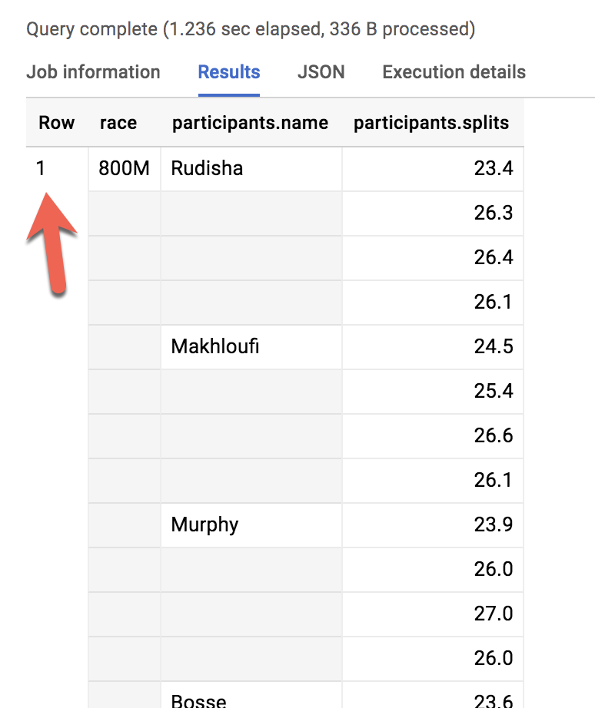

1. What if you wanted to list the name of each runner and the type of race?

Run the below schema and see what happens:

*#standardSQL*

SELECT race, participants.name

FROM racing.race_resultscontent_copy

Error: Cannot access field name on a value with type ARRAY\<STRUCT\<name STRING, splits ARRAY\<FLOAT64\>>>> at [1:21]

Much like forgetting to GROUP BY when you use aggregation functions, here there are two different levels of granularity. One row for the race and three rows for the participants names. So how do you change this...

|  |  |  |
| --- | --- | --- |
| **Row** | **race** | **participants.name** |
| 1 | 800M | Rudisha |
| 2 | ??? | Makhloufi |
| 3 | ??? | Murphy |

...to this:

|  |  |  |
| --- | --- | --- |
| **Row** | **race** | **participants.name** |
| 1 | 800M | Rudisha |
| 2 | 800M | Makhloufi |
| 3 | 800M | Murphy |

In traditional relational SQL, if you had a races table and a participants table what would you do to get information from both tables? You would JOIN them together. Here the participant STRUCT (which is conceptually very similar to a table) is already part of your races table but is not yet correlated correctly with your non-STRUCT field "race".

Can you think of what two word SQL command you would use to correlate the 800M race with each of the racers in the first table?

Answer: CROSS JOIN

1. Great! Now try running this:

*#standardSQL*

SELECT race, participants.name

FROM racing.race_results

CROSS JOIN

participants *# this is the STRUCT (it's like a table within a table)*content_copy

Error: Table name "participants" cannot be resolved: dataset name is missing.

Even though the participants STRUCT is like a table, it is still technically a field in the racing.race_results table.

1. Add the dataset name to the query:

*#standardSQL*

SELECT race, participants.name

FROM racing.race_results

CROSS JOIN

race_results.participants *# full STRUCT name*content_copy

1. And **Run query**.

Wow! You've successfully listed all of the racers for each race!

|  |  |  |
| --- | --- | --- |
| **Row** | **race** | **name** |
| 1 | 800M | Rudisha |
| 2 | 800M | Makhloufi |
| 3 | 800M | Murphy |
| 4 | 800M | Bosse |
| 5 | 800M | Rotich |
| 6 | 800M | Lewandowski |
| 7 | 800M | Kipketer |
| 8 | 800M | Berian |

You can simplify the last query by:

* Adding an alias for the original table
* Replacing the words "CROSS JOIN" with a comma (a comma implicitly cross joins)

This will give you the same query result:

*#standardSQL*

SELECT race, participants.name

FROM racing.race_results AS r, r.participantscontent_copy

If you have more than one race type (800M, 100M, 200M), wouldn't a CROSS JOIN just associate every racer name with every possible race like a cartesian product?

**Answer**: No. This is a *correlated* cross join which only unpacks the elements associated with a single row. For a greater discussion, see [working with ARRAYs and STRUCTs](https://cloud.google.com/bigquery/docs/reference/standard-sql/arrays#flattening-arrays)

Click *Check my progress* to verify the objective.

Practice with STRUCTs and ARRAYs

Check my progress

Recap of STRUCTs:

* A SQL [STRUCT](https://cloud.google.com/bigquery/docs/reference/standard-sql/data-types#struct-type) is simply a container of other data fields which can be of different data types. The word struct means data structure. Recall the example from earlier:
* __STRUCT(__"Rudisha" as name, [23.4, 26.3, 26.4, 26.1] as splits__)__AS runner
* STRUCTs are given an alias (like runner above) and can conceptually be thought of as a table inside of your main table.
* STRUCTs (and ARRAYs) must be unpacked before you can operate over their elements. Wrap an UNNEST() around the name of the struct itself or the struct field that is an array in order to unpack and flatten it.

**Lab Question: STRUCT()**

Answer the below questions using the racing.race_results table you created previously.

**Task:** Write a query to COUNT how many racers were there in total.

To start, use the below partially written query:

*#standardSQL*

SELECT COUNT(participants.name) AS racer_count

FROM racing.race_resultscontent_copy

**Hint:** Remember you will need to cross join in your struct name as an additional data source after the FROM.

Possible Solution:

*#standardSQL*

SELECT COUNT(p.name) AS racer_count

FROM racing.race_results AS r, UNNEST(r.participants) AS pcontent_copy

|  |  |
| --- | --- |
| **Row** | **racer_count** |
| 1 | 8 |

Answer: There were 8 racers who ran the race.

**Lab Question: Unpacking ARRAYs with UNNEST( )**

Write a query that will list the total race time for racers whose names begin with R. Order the results with the fastest total time first. Use the UNNEST() operator and start with the partially written query below.

Complete the query:

*#standardSQL*

SELECT

p.name,

SUM(split_times) as total_race_time

FROM racing.race_results AS r

, r.participants AS p

, p.splits AS split_times

WHERE

GROUP BY

ORDER BY

;content_copy

Hint:

* You will need to unpack both the struct and the array within the struct as data sources after your FROM clause
* Be sure to use aliases where appropriate

Possible Solution:

*#standardSQL*

SELECT

p.name,

SUM(split_times) as total_race_time

FROM racing.race_results AS r

, UNNEST(r.participants) AS p

, UNNEST(p.splits) AS split_times

WHERE p.name LIKE 'R%'

GROUP BY p.name

ORDER BY total_race_time ASC;content_copy

|  |  |  |
| --- | --- | --- |
| **Row** | **name** | **total_race_time** |
| 1 | Rudisha | 102.19999999999999 |
| 2 | Rotich | 103.6 |

**Lab Question: Filtering within ARRAY values**

You happened to see that the fastest lap time recorded for the 800 M race was 23.2 seconds, but you did not see which runner ran that particular lap. Create a query that returns that result.

**Task:** Complete the partially written query:

*#standardSQL*

SELECT

p.name,

split_time

FROM racing.race_results AS r

, r.participants AS p

, p.splits AS split_time

WHERE split_time = ;content_copy

Possible Solution:

*#standardSQL*

SELECT

p.name,

split_time

FROM racing.race_results AS r

, UNNEST(r.participants) AS p

, UNNEST(p.splits) AS split_time

WHERE split_time = 23.2;content_copy

|  |  |  |
| --- | --- | --- |
| **Row** | **name** | **split_time** |
| 1 | Kipketer | 23.2 |

**Congratulations!**

You've successfully ingested JSON datasets, created ARRAYs and STRUCTs, and unnested semi-structured data for insights.